**Experiment No:** 03

**Experiment Name:** View how active process work in terminal

**Aim and Objective:** To know about how some process command work on linux.

ls -> Used to list folder contents.  You can view many kinds of file and folder attributes.

1. ls By itself, ls will simply list all your files in the current folder.From fact #4, this literally does ls

Screenshots:

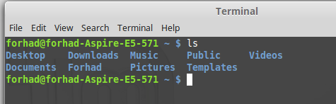

2. ls -l Provides a longer listing format including owners, permissions, size, and date modified.

Screenshots:

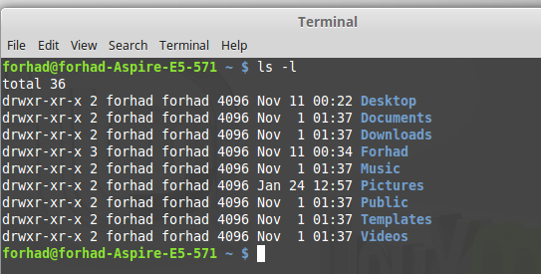

3. ls -a Displays hidden files and folders as well as the normal listing.

Screenshots:

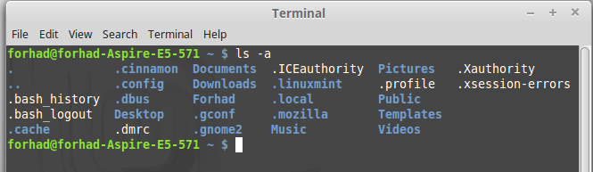

4. ls -al Combine options to display both hidden files and in the long format.

Screenshots:

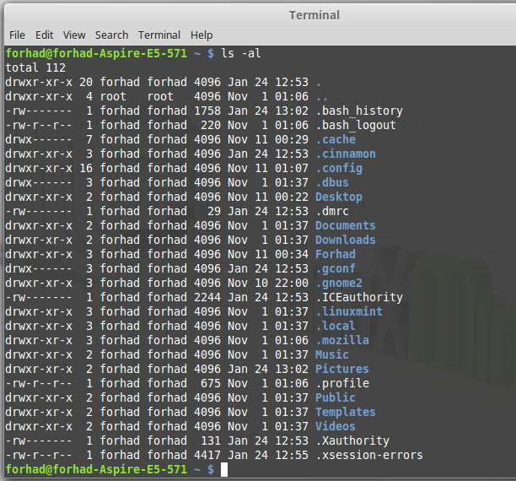

5. ls -h Show file sizes in human readable format (K, M, Gbyte) filesizes instead of bytes.  Often used in conjuction with the -l flag.

Screenshots:

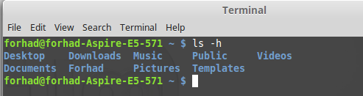

ps -> List processes:

ps aux: List all processes in detail running on the system, including user, Process ID (PID), and

name of process.  Using this, one can view their process list and if necessary, kill unnecessary or stalled processes.

Screenshots:

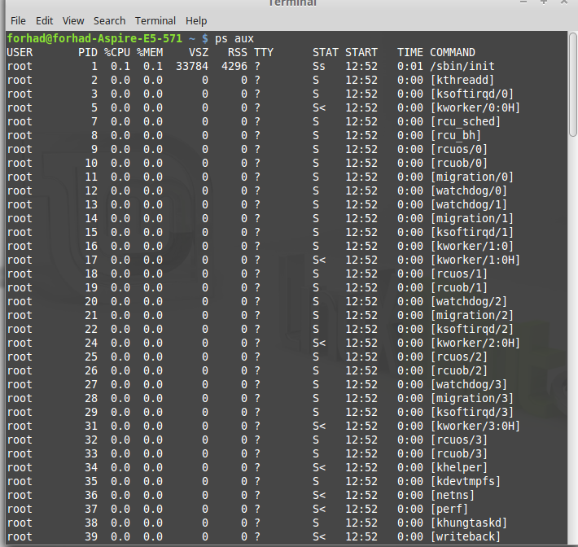

kill / killall / xkill -> Kill offending processes:

1. kill PID: PID is a number referencing the offending process.  One should obtain the PID from a command like ps aux.  If a process refuses to die, one can alternatively specify kill -9 PID which should terminate the process by any means, even uncleanly or if it will mess up the system.

Screenshots:



2. killall program: Killall kills *by name* all instances of said program.  If there are for example 3 firefox sessions and codeblocks session open, killall firefox and killall codeblocks will do just that; kill all firefox session and codeblocks session.  kill would simply take the specified PID of the offending firefox and codeblocks process you wish to kill, and kill that one only.

Screenshots:

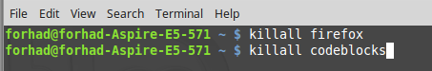

3.xkill: xkill is a GUI way to click and kill windows.  Typing in xkill should present a skull-and-crossbones icon, and the next window clicked on will be killed.

Screenshot:

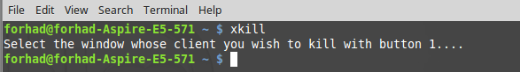

Quick tips:

1. Lost yourself in a directory?  Not sure where you are?  Type pwd to print working directory.

Screenshot:

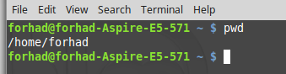

2. Want to calculate your disk space quickly?  df -h can give you a quick checkup.

Screenshot:

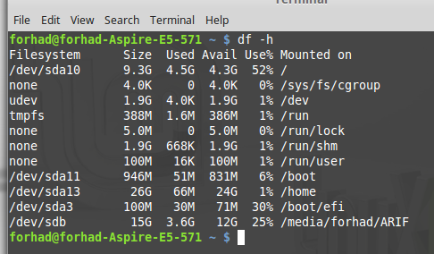

3. Want to calculate the size of a folder or file quickly?  du -cksh target_name can do exactly that.  Want to calculate the size of the current folder?  du -cksh .

Screenshot:

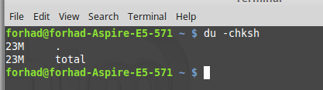

**Conclusion:** In this lab, we have to learn about how to working procedure of basic linux process. We have successfully done it with basic linux process. It helps us to make more efficient of the future in Linux operating system.